January 26, 2021

Dear [Student Name],

I am writing to confirm that you have been offered a position as a(n) [Insert Job Title] for the [Insert Semester]

[Insert Job Title] are expected to work [Insert hours per week] and will be paid [Insert Hourly Wage]. Your anticipated start date is [Insert Start Date].

We are excited to extend this offer to you and if you have any questions, please don’t hesitate to reach out!

Sincerely,
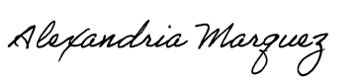
Alexandria Marquez
International Student Advisor
[Contact Email] | [Phone Number]

